**UST AGAIN – The Reuse Hackathon 2019**

**MEXICO TEAM**

**METRIC CHART GENERATOR**

* Team Leader: Alejandro Garcia (UST, MEX) [Alejandro.Garcia@ust-global.com](mailto:Alejandro.Garcia@ust-global.com)
* Team Leader Account: COTIVITI
* Team Leader Location: Leon, Mexico
* Other Team members 1(Optional): Fabricio Guerrero (UST, MEX) [fabricio.guerrero@ust-global.com](mailto:fabricio.guerrero@ust-global.com)
* Other Team members 2(Optional): Samuel Santos (UST, MEX) [Samuel.Santos@ust-global.com](mailto:Samuel.Santos@ust-global.com)
* Component Being Proposed: **Metric Chart Generator**

**Concept**

**Introduction**

UST Global has a wide variety of customers from different economic sectors, to whom development services are provided, either UST-managed or Customer-managed service delivery, most of them working with agile methodologies such as SCRUM or Kanban for their Software Development projects.

As a software development and service delivery sector nature, having the right information and key visibility is highly important to enable an efficient decision making within any company and more for this kind of economic nature.

On the other hand, Agile methodologies (Scrum, Kanban, XP, etc.) are widely used among the software development and IT services companies. Therefore, program, project and team measurement tracking are required thru the agile project lifecycle and there are several tools in the market (Excel, JIRA, Trello, etc.) that are used to measure different KPI’s within lines as project performance, resource planning, project/resource capacity, budget/revenue, etc.

So, one of the most important issues related to the project, product or process measurements is related with the complexity of gathering and integrating different data (project, resource, financial, team, etc.) since most of them are coming from more than one data source such as Databases, Files or other ALMs (Trello, JIRA, Rational, etc.) systems within a single company. This limitation derives on the complexity to build the visibility the top management requires within a single pane view, to enable a better decision making in a fully supported way.

Additionally, other main challenges to achieve this single pane view are the following:

* No capacity to work with multiple data sources.
* Working with RAW data is hard and need to be converted into indicators.
* High complexity to build Key Project/Process Indicators as needed, and normally trend to hardcode formulas or data manipulation features.
* Solutions or components that are not web have limitations to work with when working with different platforms (web/mobile) that require responsive capabilities.
* No capacity to work with cross multi-costumer/area/division/etc. information.
* Working with data considering the above normally to not have enough security protection level.
* Rigid functionality.
* Lack of technical knowledge from business users which are normally the stakeholders of these requirements.

These needs are what drives our team to bring **Metric Chart Generator**, a component/solution with several reusable components focused on providing a build-as-you-need-it chart component that can be embedded into any web page. This component/solution will ease the generation of a multi-management level charts, enabling the processing from different data sources the configuration of self-made KPI’s, adapting as much as possible to the business visibility needs.

**Purpose**

The main purpose of the component, as mentioned before is to enable the generation of key processes/product/etc. metric charts that can be embedded within any web/mobile platform, completely fed by indicators built from data imported from one or more data sources.

The most important value of this component is the ability to generate indicators thru a set of construction rules/operations (formulas) such as conditionals, operations and conversions.

Other main opportunity areas this solution will attend are:

* Ability to cross information from different data sources.
* Ability to build indicators from these data inputs.
* Ability to generate a chart (different types) from those indicators.
* Ability to generate chart code that can be inserted/embedded into any web/mobile application.

**Project Description**

The Metric Chart Generator is a Web Component (which can work as a solution itself) that generates charts from indicators built with a set business rule catalog fed by data imported from one or more data sources (file, database object, API) that can be pulled all at the same time.

The solution is intended to work with Agile Project data but can be used for almost any kind of data sets.

This component/solution will enable a user to:

* Generate a Chart from indicators step by step thru a friendly wizard.
* Configure a data source, step by step (connection, data source, data type, data mapping) thru a friendly wizard.
* Publish finished chart to be embedded/viewed in a web site/page.
* The export chart feature can convert the chart into a PDF format if needed.
* The component can generate as much charts as needed enabling the user to generate a self-made ad-hoc dashboard.

This solution can be used and reused by multiple people, applications for multiple purposes, as this web component can be integrated to a bigger application or only used as a stand-alone functionality component/application.

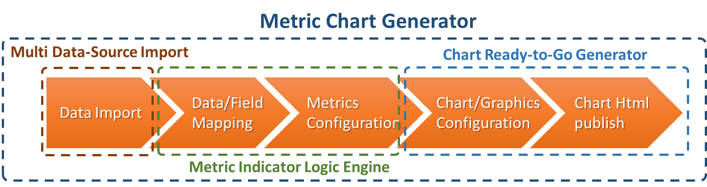

The component will be developed with an MVC architecture using the .NET Core framework with C# for the Back-End, Angular for the Front-End, and REST Services for the integration/communication layer. The Front-End will use Angular capabilities to allow responsive functionalities such as fitting screen sizes going from cellphones to desktop computers, and the use of lazy loading to adapt to different kind of devices allowing the solution to remain fast in the execution.

Additionally, this application will have a “user configurable features/tools” where the user will can build his/her own metrics/indicators, graphics. will be able to customize the report being created.

Front

Configuration

Layout

Publishing

Client X - Scrum

Main sub components are:

* **Data Import.** Allows to define the data source name and its type (file, database, API). Allows also to configure the data source access credentials (link, user and password) according to the data source type. Also, this feature will allow to test the connection.
* **Data Field Mapping.** Allows the section to map specific data/field from data source to a specific field on the component with specific parameters that will govern the data importing/reading.
* **Metrics Configuration.** Allows the selection of built-in indicators or the generation of new ones from allowed fields from the configured data source.
* **Chart/Graphic Configuration.** Allows to configure a built-in graphic or a new one using the defined metrics.
* **Chart HTML Publish.** Will enable to previsualize the Chart before publishing. When the chart is published, the component creates an html page with the chart embedded or can generate the code to be inserted in another web page to load the chart into a specific frame.